**Software Requirements Specification (SRS) for Patient Management System**

**Table of Contents**

* Introduction
* System Overview
* Functional Requirements
* Non-Functional Requirements
* Database Schema
* User Interface Design
* System Architecture

**1. Introduction**

The Patient Management System is a software application designed to streamline the process of managing patient information in a healthcare setting. This system enables healthcare professionals to record patient details, generate prescriptions, and maintain patient records efficiently.

**2. System Overview**

The system provides functionalities for:

User authentication through a login interface.

Adding, updating, deleting, and searching patient records.

Generating and saving patient prescriptions.

Displaying patient information in a tabular format.

**3. Functional Requirements**

User Authentication:

Users should be able to log in using their username and password.

Only authenticated users can access the system.

Patient Management:

Add Patient Record: Users can add new patient records with details such as name, date of birth, address, etc.

Update Patient Record: Users can modify existing patient records.

Delete Patient Record: Users can remove patient records from the system.

Search Patient Record: Users can search for specific patient records by name.

Prescription Management:

Generate Prescription: Users can generate prescriptions with details of prescribed medications, dosage, etc.

Save Prescription: Users can save generated prescriptions as text files.

**4. Non-Functional Requirements**

Performance:

The system should respond promptly to user actions, ensuring efficient data retrieval and processing.

Security:

User authentication should be secure to prevent unauthorized access to patient information.

User Interface:

The user interface should be intuitive and easy to navigate, facilitating user interaction with the system.

**5. Database Schema**

The system interacts with a MySQL database with the following schema:

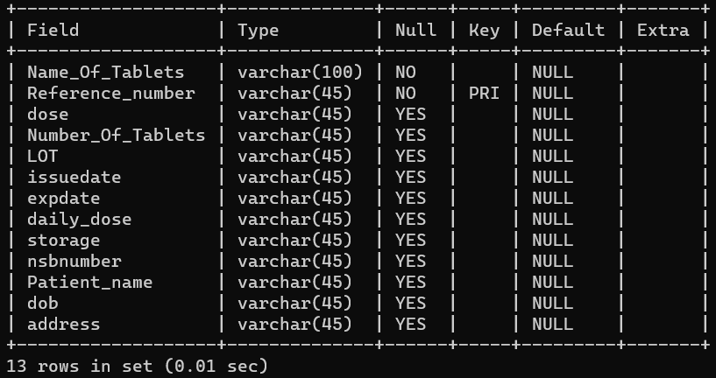**6. User Interface Design**

The user interface is implemented using Tkinter, a Python GUI toolkit. It consists of various widgets such as Labels, Entries, Buttons, Comboboxes, and Text areas for data input, display, and interaction.

**7. System Architecture**

The system follows a client-server architecture where the client application interacts with the MySQL database hosted on a server. The client-side application handles user interactions, while the server-side manages data storage and retrieval.